CS 255 System Design Document Template

This template lays out all the different sections that you need to complete for Project Two. Each section has guidance to prompt your thinking. You will need to continually reference the interview transcript as you work to make sure that you are addressing your client’s needs. There is no required length for the final document. Instead the goal is to complete each section based on what your client’s needs are. Remove this note when you are finished, and replace all bracketed text with the relevant information.

UML Diagrams

UML Use Case Diagram
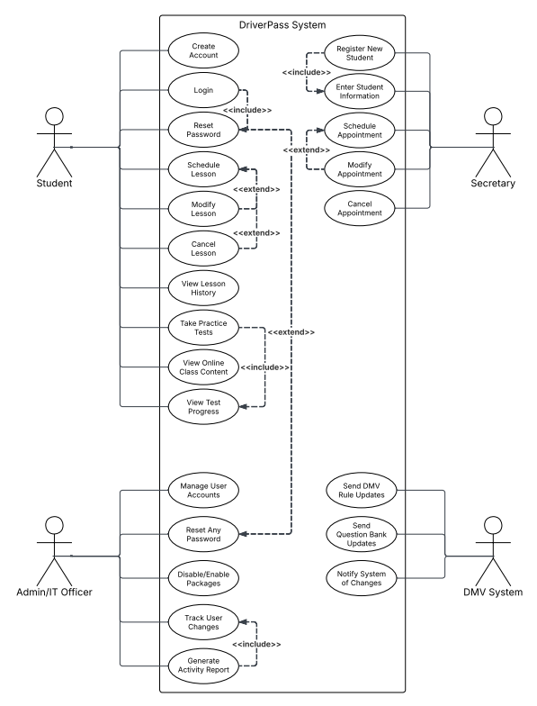

UML Activity Diagrams
Schedule Lesson Diagram
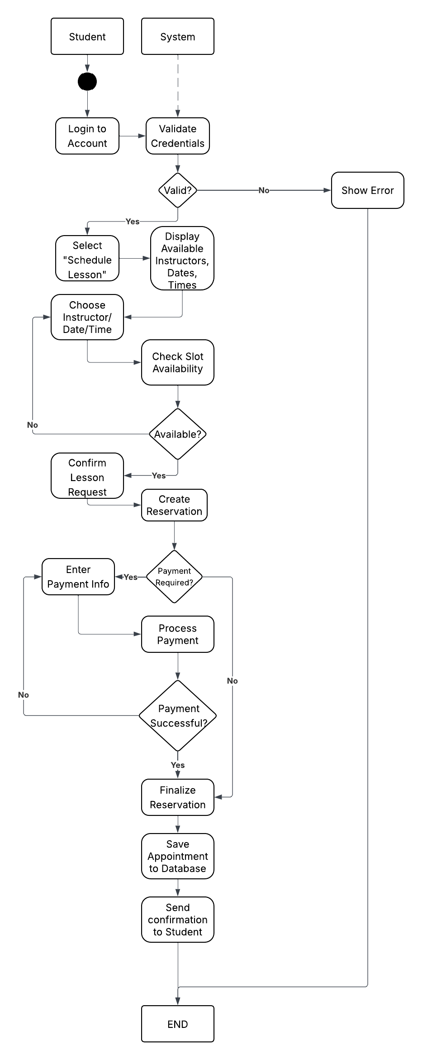
Take Practice Test Diagram
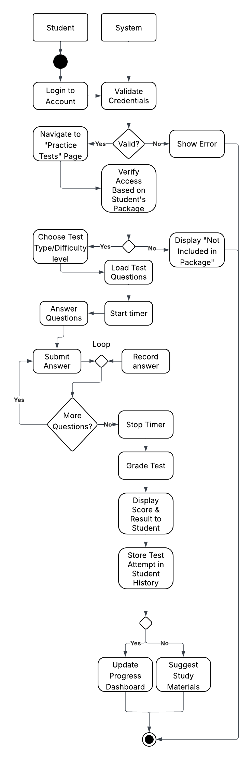

UML Sequence Diagram
Take Practice Test Diagram
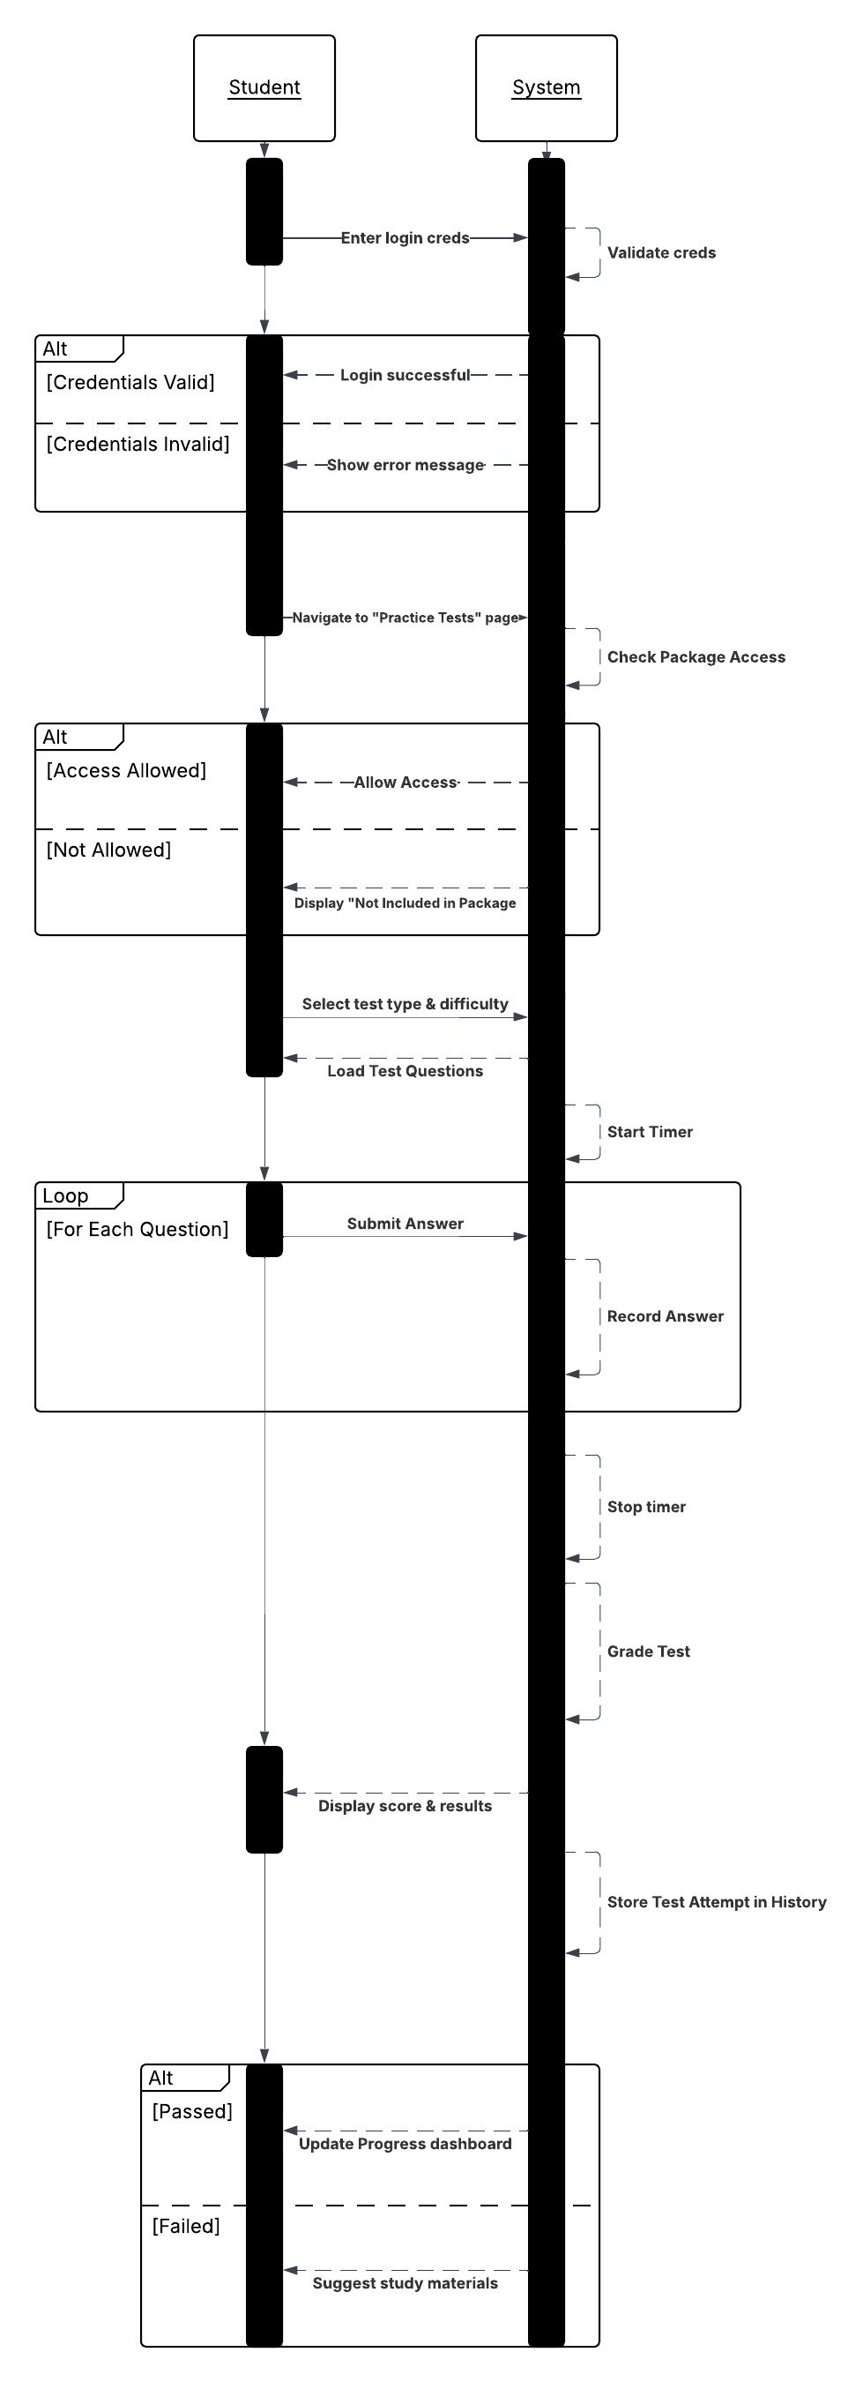

UML Class Diagram
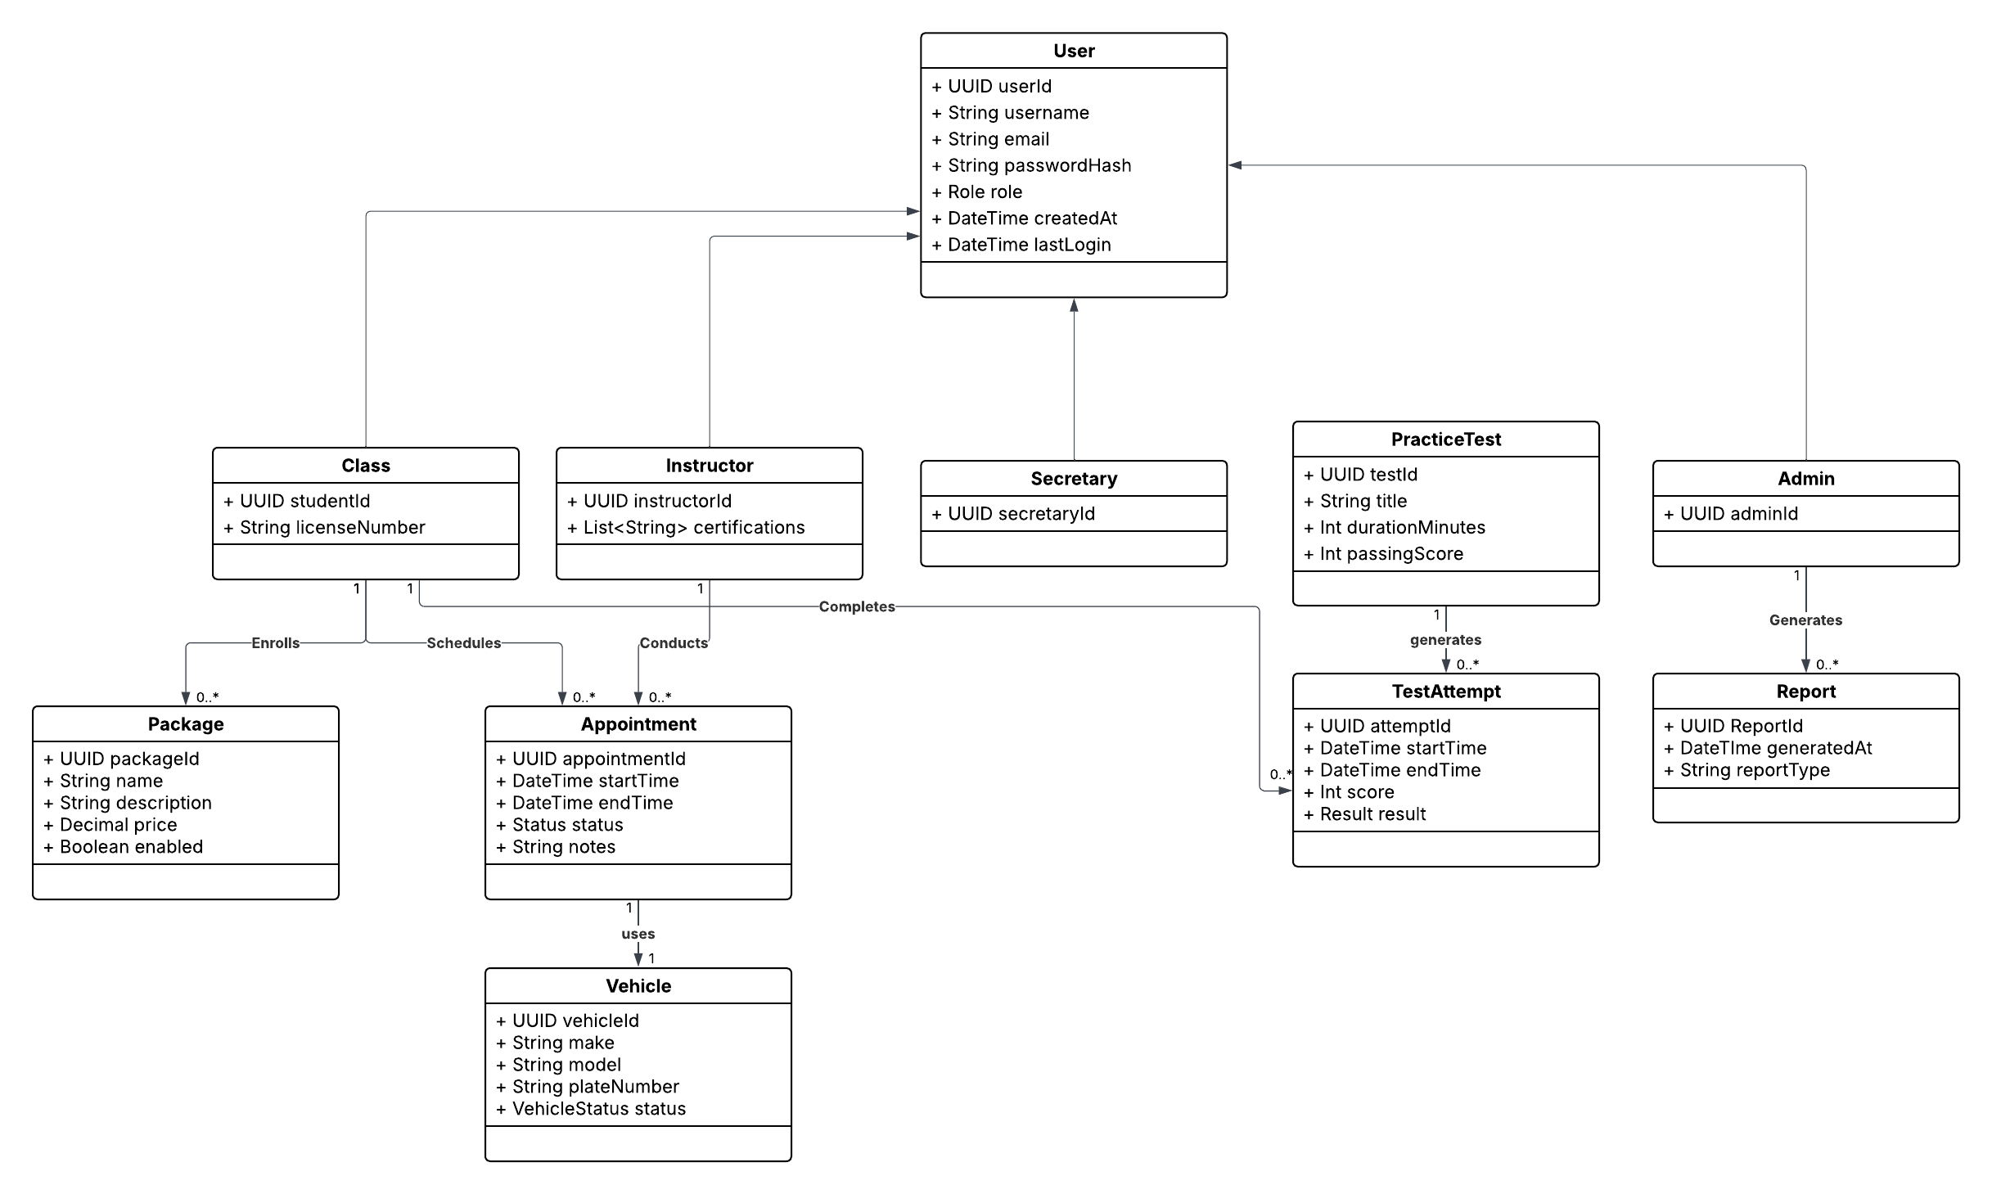

Technical Requirements
- Hardware
- Cloud Servers: Host app servers and database on managed cloud (like Azure). Start with two small to medium instances behind a load balancer for high availability, with autoscaling enabled.
- Storage: Manage user data in a secure database and store course materials and reports in online file storage.
- Content Delivery: Static content like images and videos will be delivered efficiently to improve page load speed.
- Backups: System data will be backed up daily and kept for recovery purposes.
- Software / Stack
- UI: Web-based interface that works on desktop and mobile. (Frontend)
- Application Server: System that handles logins, scheduling, tests, and payments. (Backend)
- Database: Relational database to store user accounts, appointments, test results, and reports.
- Authentication: Secure login with encrypted passwords and session management.
- Payments: Online payment processing for lesson packages.
- Notifications: Email and text message notifications for appointments and account updates.
- Testing and Updates: Automated tools to test the system and deploy updates safely.
- Monitoring and Logging: Tools to track system performance and record system activity for troubleshooting.
- Infrastructure / Services
- Role-based access control (RBAC): Different access levels for students, instructors, secretaries, owners, and admins
- DMV updates: The system will update the practice test content based on DMV changes
- Security: Secure connections, protection against unauthorized access, and safeguards for sensitive data.
- Backup & Recovery: Data recovery plans to restore the system in case of failure.
- Scalability: The system can handle increased users and activity as DriverPass grows.
- Reporting: Admins and owners can generate and download reports for business tracking.
- Nonfunctional Constraints
- Pages should load within 3 seconds on typical broadband.
- 24/7 availability
- All course material updates reflecting DMV policy within 48 hours of DMV feed changes.

